Create a DB View based on one table and View records.

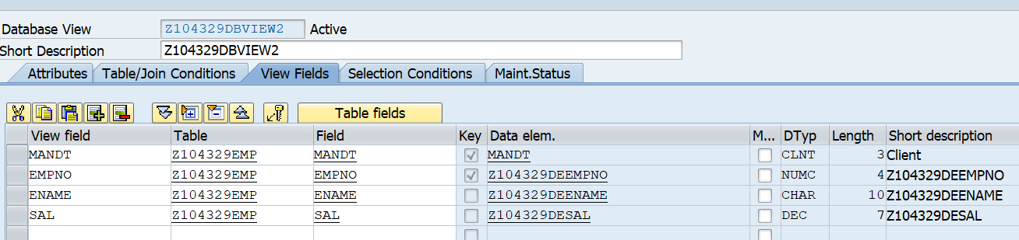

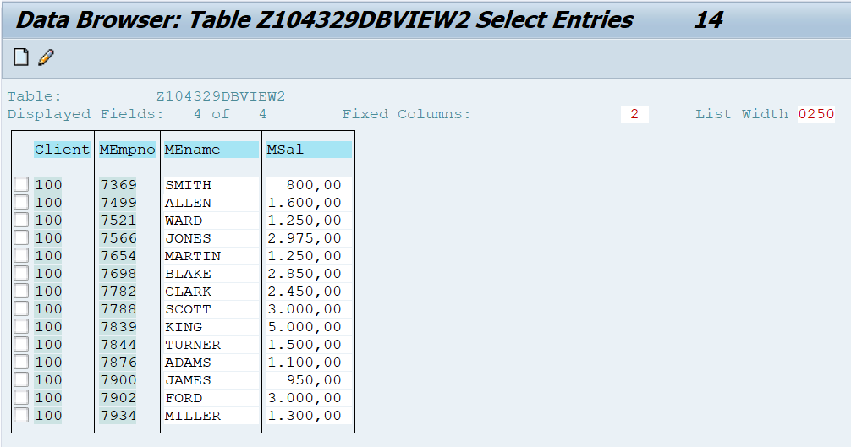

**Note: TMG is disabled.(Utilities - Table Maintenance Generator)**

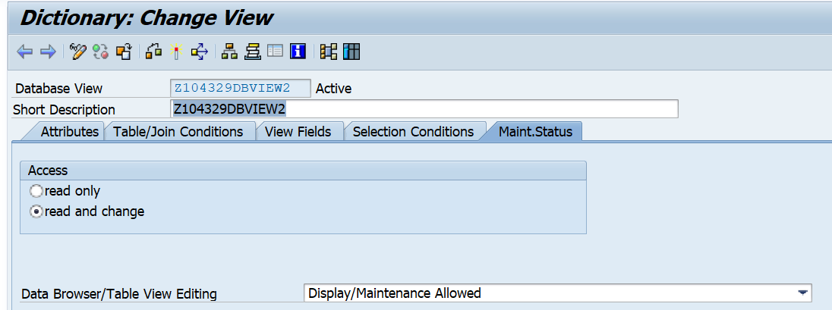

Execute the below program to insert record in the view.

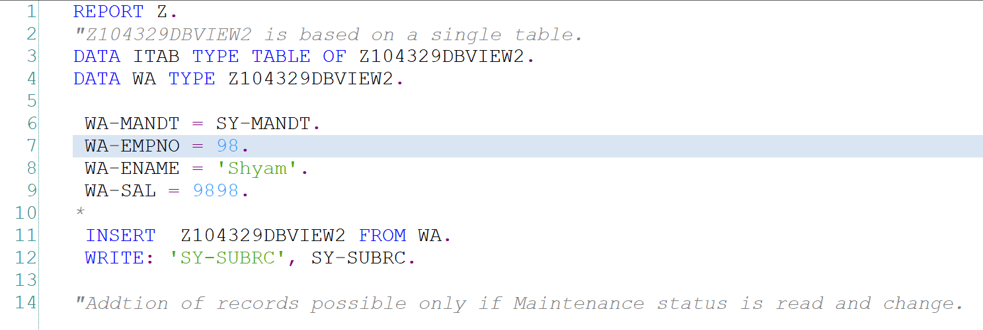

View the added record in the View in SE11.

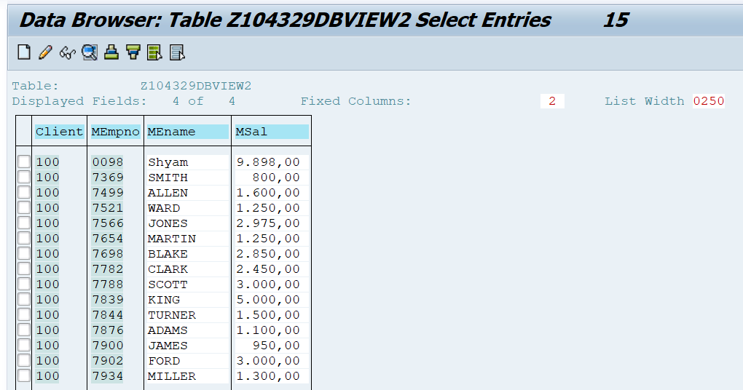

View the added record in the table emp in SE11.

